The 2023 Papa Stronsay Calendar is now available!
Giving you the liturgical feast and colour of each day of the year, the calendar also includes other information such as particular feasts, traditional days of abstinence, saints’ anniversaries, the liturgical zodiac, the phases of the moon, public holidays of eight English-speaking countries and more.
Each month features a picture from the Holy Island of Papa Stronsay, or of Transalpine Redemptorist activity elsewhere around the world.
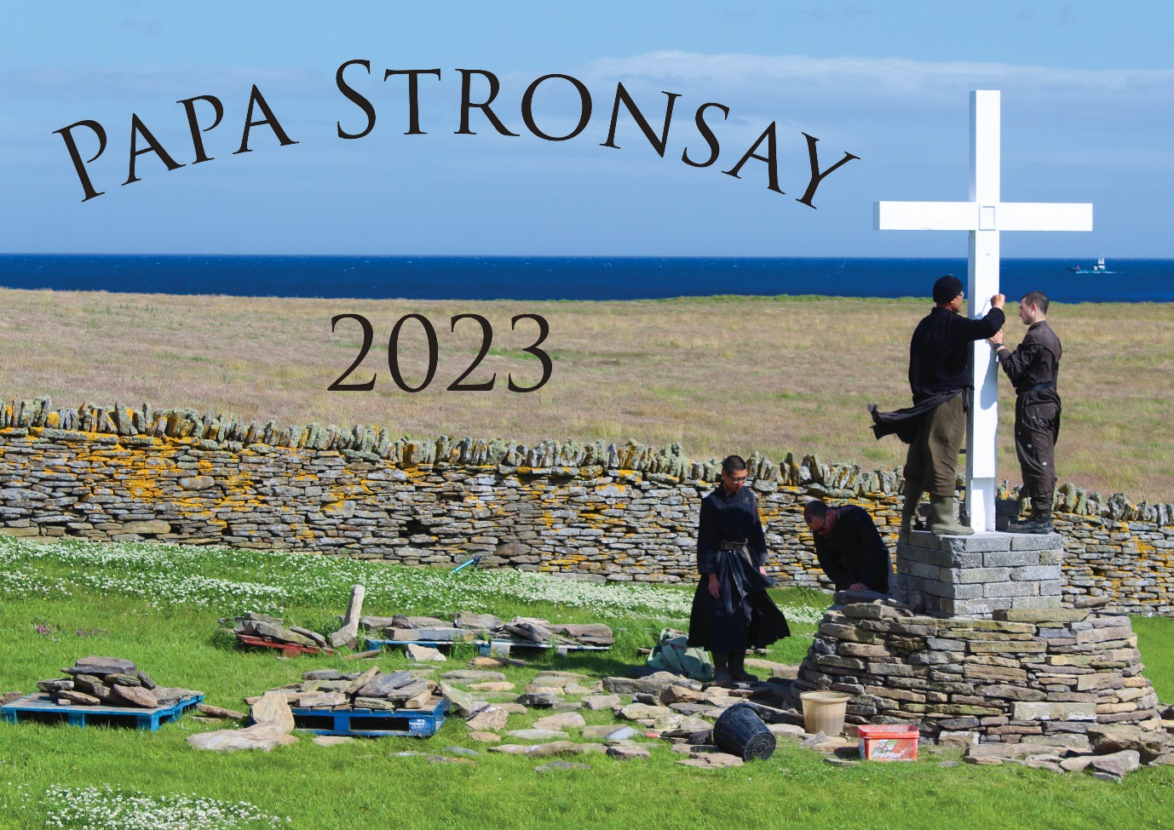
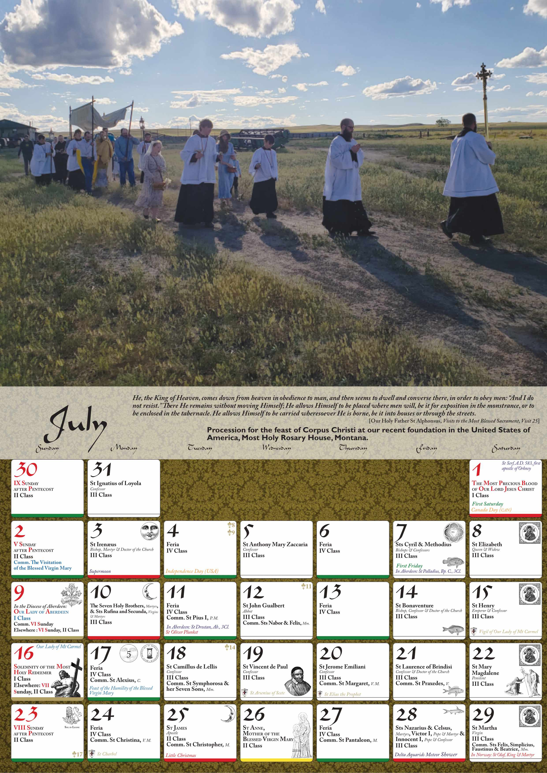

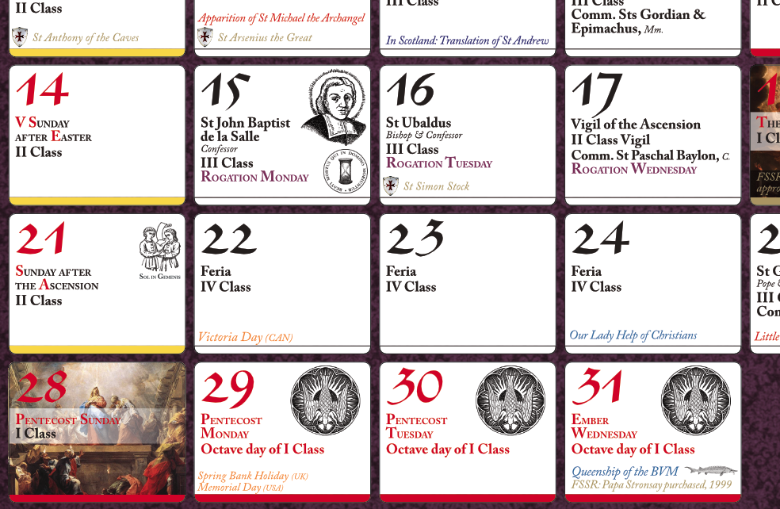
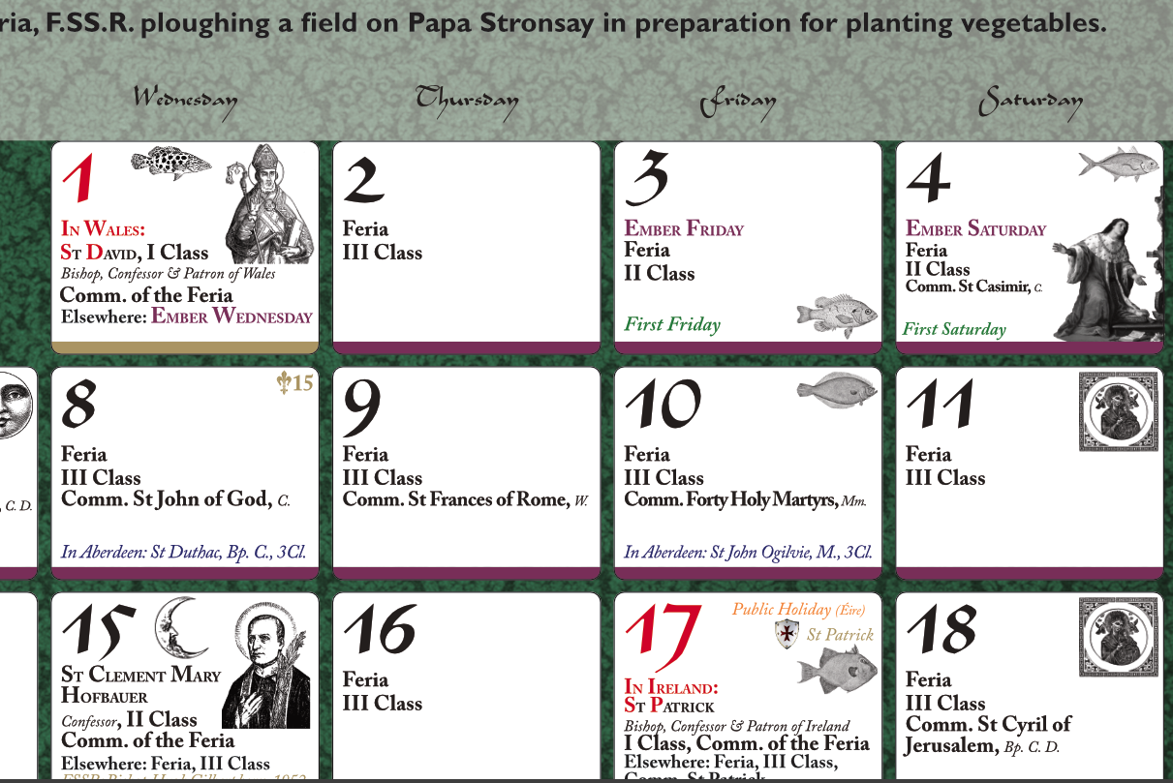
Thank you for your support, and may God bless you!

